Cadet’s and Parent’s Illustrated Guide to USNSCC
Recruit and Advanced Training Signup Procedure

Introduction: One of the key goals of the USNSCC is to keep our Cadets steadily progressing. One of the key enabler’s to rank advancement and the exciting opportunities presented by the USNSCC is Advanced Training. This guide covers both Recruit Training (RT) and Advanced Trainings (AT). In order for cadets to qualify for any of the ATs, they must first attend either a 9-day or a 14-day Recruit Training. NOTE: Due to the Corona virus of 2020, Recruit Trainings will be a combination of Virtual and In-Person training. Cadets must participate in both to pass.
Recruit Training Requirements: To qualify for recruit training, Cadets must have been enrolled for a minimum of 3 months. Prior to attending RT, recruits are required to complete the BMR (Basic Military Requirements). In some circumstances, the Commanding Officer (CO) can make exceptions and approve certain cadets to attend having only completed a subset of the BMR chapters. Most (if not all) RTs now require that cadets complete an on-line set of questions that can be done as an open-book test.

Accessing Training Opportunities:
- On your web browser enter: USNSCC Homeport. You should see an image like the one below:

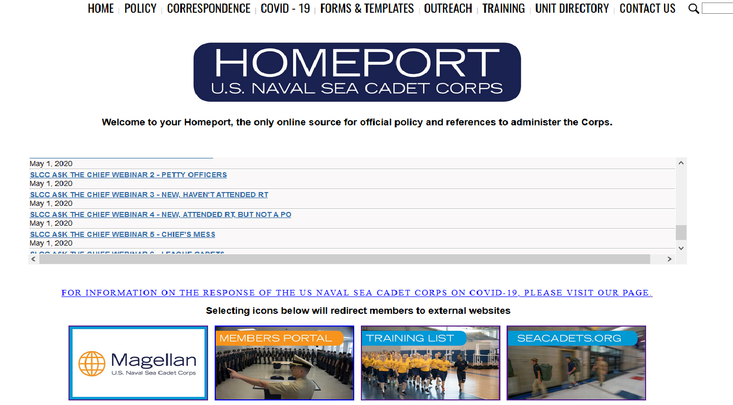

- Select the “Training List” Button. You will see a screen like the one below. Select “Winter Training – Sea Cadet Corps.”

You will then see a screen that looks like the one below. What confuses some cadets and parents is knowing where the various training opportunities fit within the categories. “Navy Shore” is the catchall for many activities that are difficult to categorize. Otherwise, you may have to hunt around a bit. But use this as an opportunity to understand the vast range of trainings that are available.

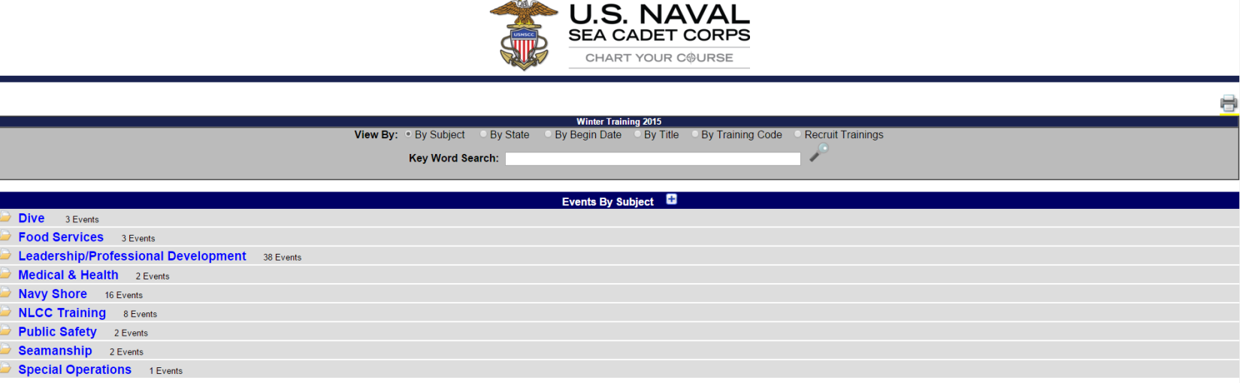
If you are looking for recruit training or other hard to categorize activities, select “Navy Shore.” The Screen will look like the one below. The expanded list shows all trainings under Navy Shore.
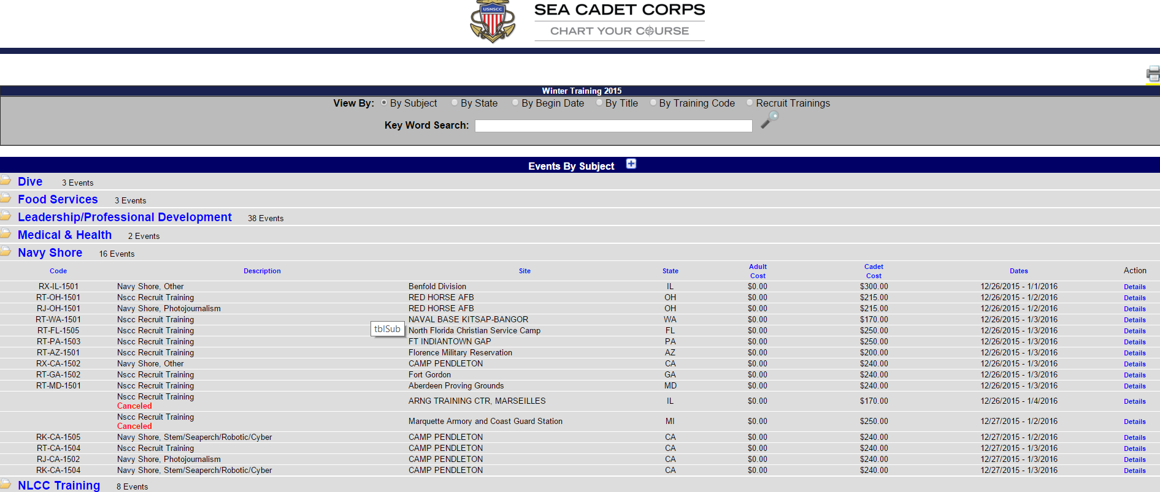
Select “Details” (in blue and on the right) for the training that interests you. For this example, we will look at NSCC Recruit Training in AZ. You will see a page that looks like the screen shot below. There is very important information on this page that you need to pay attention to: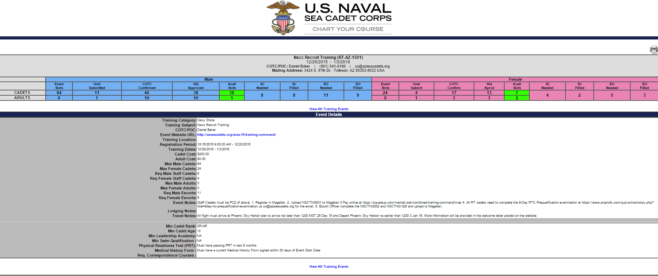
- Please note the very top which has specific information that you will need to know:
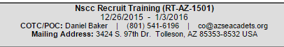
Here we see the training code (RT-AZ-1501). We see the Commanding Officer of the Training Contingent (COTC) point of contact (POC) information.
- The next bar shows how many slots are available. If the number available is “0”, you need to find a different training. Note that there are separate slot availabilities for male and female cadets. In this case, there are 38 slots available for male cadets and 7 slots for female cadets.
- The next portion contains critical information that MUST NOT BE IGNORED.
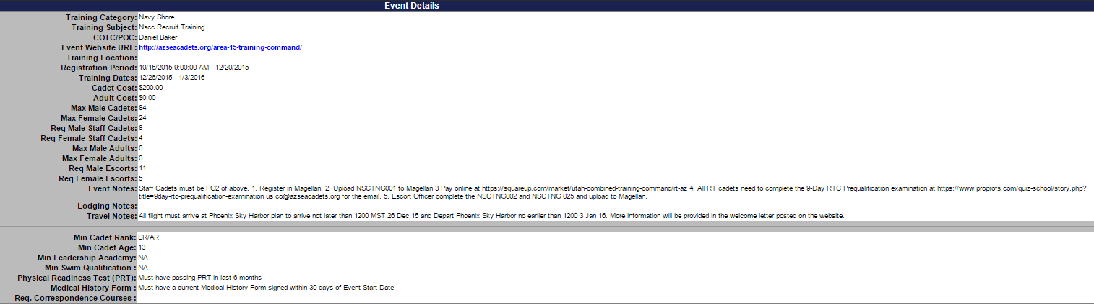

Please pay special attention to the Event Website URL (shown in blue). Here we see where to go to find specific information for this training location. In this case, it is a blue hyperlink. You will select it after we discuss the rest of this page. Note also that it restates the dates and the cost of the training.
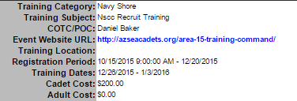

The next critical item are the Event Notes and the traveling notes: Note: Due to Corona virus 2020, only in-state travel is allowed.

Review the event notes and the travel instructions.
Another critical area are the qualification requirements (see figure below).
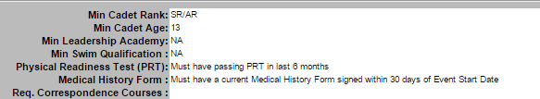

Note here that there is a minimum rank, age, requirement for successful passing of the Physical Readiness Test (PRT) and a medical history form signed within 30 days of the event. We will discuss this form (NSCTNG001) a bit later.
Go to the Event URL:
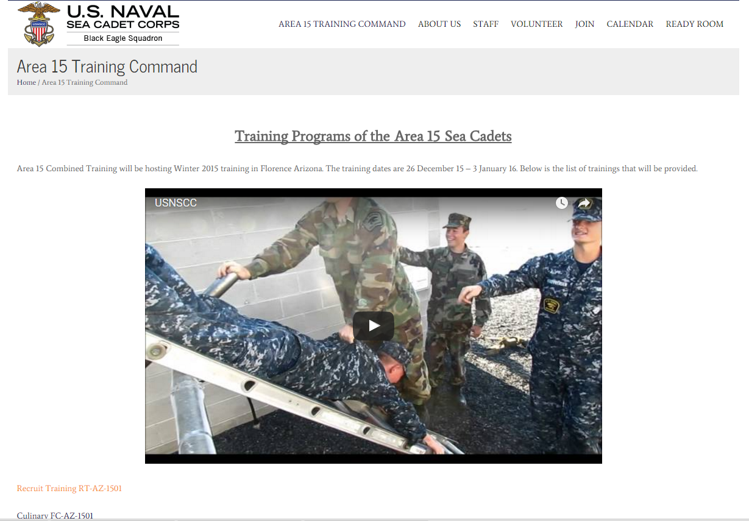
EACH TRAINING WILL HAVE A DIFFERENT WEB SITE AND SLIGHTLY DIFFERENT INSTRUCTIONS!!
Here we see a video, and below the video, a list of trainings. The picture above does not list all of the trainings since the screen capture cut it off, but you can see the Recruit Training. Select the “Recruit Training RT-AZ-1501” link. You should see a page like the one below:
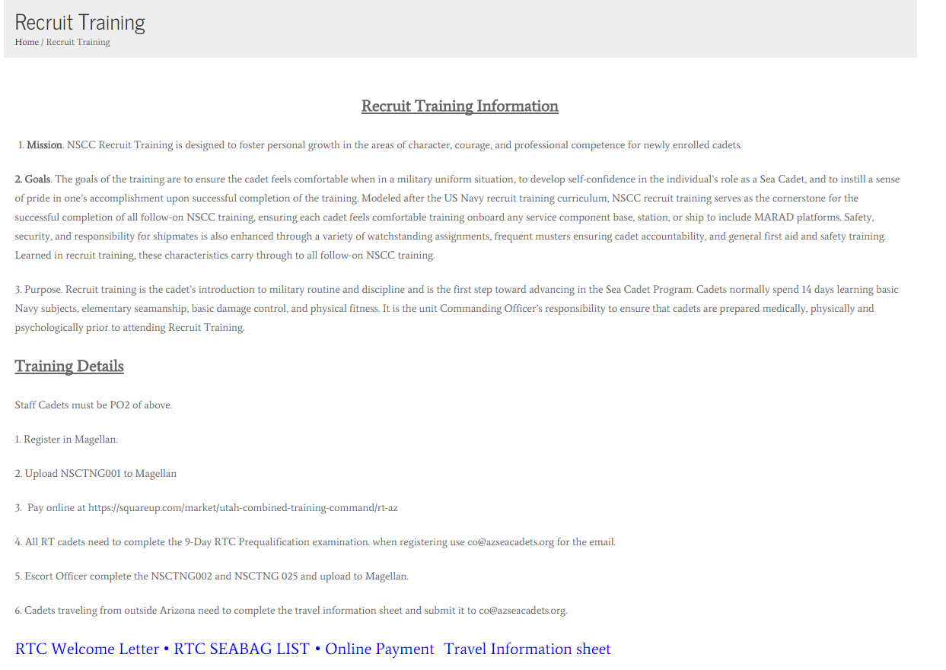
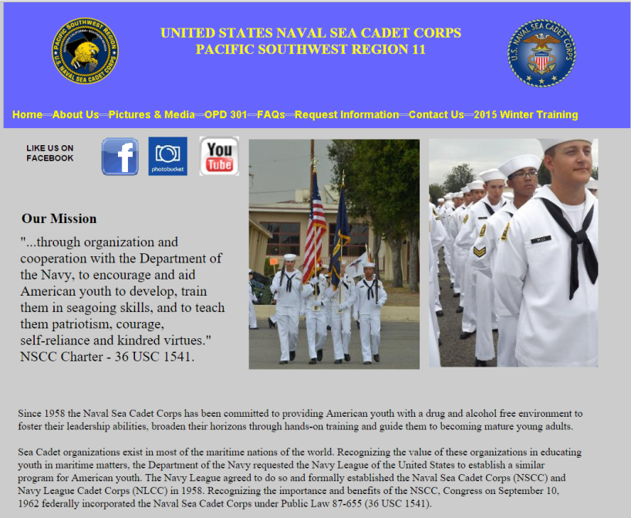
If you were going to a Camp Pendleton Training, the Event Website URL page would look like the one RIGHT. To access more detailed instructions, you need to click on the upper right hand corner reading “2015 Winter Training.” That will lead you to a very detailed webpage with explicit instructions. All trainings supply this kind of detailed instruction, but you need to follow the above steps to find it.
Review the materials. PRINT (!) the Welcome Letter, Sea Bag List and Travel Information Sheet.
ONCE YOU HAVE Confirmation, Follow the “On-line Payment” Instructions. YOUR CADET WILL NOT EVEN BE CONSIDERED IF IT IS NOT PAID FOR IN ADVANCE. DO NOT PAY FOR TRAININGS THAT ARE FULL!!

NOTE: YOU CANNOT REGISTER YOUR CADET IN MAGELLAN. THIS WILL BE DONE BY THE UNIT. SEE INSTRUCTIONS BELOW ENTITLED: HOW TO INITIATE TRAINING

How to Initiate Training
It is important to understand that direct registration for trainings in Magellan is not done
by cadets or parents. It must go through the unit
Once you and your cadet determine which course he/she wants to take and have verified that the cadet meets the qualifications (!), the Cadet (not the parent or guardian) should send the CO an email (address available on every POM) stating that he/she would like to register for a training, specifying the name and ID of the requested training (i.e. “Recruit Training 2015, (RT-AZ-1501)”). The CO and start the process in Magellan. There are then a number of forms required to get the cadet signed up, and it is most helpful and saves time to have the forms filled out as completely as possible!
The CO will respond to the Cadet with an Email that includes the first form, NSCTNG001 “Request for Training Authority (Cadet)”, and a screen shot of the specific training that he/she has selected. The NSCTNG001 form should have most of information already filled out based on information on file with Magellan. If any information is incorrect, please correct with a single line-out and correct information written above, initial and sign the form and submit it back to the CO.
The CO will review it for completeness sign the form. The CO will then register the cadet. Upon notification of successful initial enrollment, the CO will send the next form, NSCADM 001 “Report of Medical History” (pages 3-4 ONLY). The first form, NSCTNG001, should have some information already filled out including the Unit Name: Jake Garn Squadron; and the Region: 15-1, plus information that is on file with Magellan.
Please note: The NSCADM 001 Medical History Form does NOT have to be signed by a physician for this (we have the full form on record, signed by your primary care physician). The purpose of this form is to ensure that nothing significant has changed in your Cadet’s health. The form must be completed, signed and dated WITHIN 30 DAYS OF ARRIVING AT TRAINING. If it is signed outside this 30 day window, IT WILL BE REJECTED AND YOU WILL HAVE TO COMPLETE THE FORM AGAIN. If your Cadet is on prescription medications, you will need to request Medical History Supplemental form which are pages 7-8 of the NASCADM 001.
It is now CRITICAL that your Cadet review the Sea Bag List well in advance of the departure for training. These lists are very useful and comprehensive, and detail what items are necessary and sufficient for the training. If additional uniforms are required by the training, uniforms and NAMETAPES will have to be obtained from Supply. NAMETAPES take time to order so do not delay in advising the unit that they are needed. The same goes for dress uniform name plates!! It is your cadet’s responsibility to ensure that he/she has the uniforms necessary, that they are properly cleaned, ironed and ready for inspection at the training. Ribbons should be in proper order and prepared to be worn at graduation (and any time training would require they be in dress blues/whites).
Travel should be arranged, paid for, and an itinerary provided to the CO. The Itinerary will be placed prominently in the Cadet’s service jacket (personnel file) that they will take to training. NOTE: Due to the Corona virus of 2020, no out of state travel is allowed and thus, no itinerary is necessary.
Note: The USNSCC recommends that refundable tickets be purchased in the event of Cadet Illness or unexpected cancellation. This is an individual family decision.
FINALLY:
The Service Jacket (ie, admission ticket to training)
The CO will work with Admin to prepare and seal in an envelope, the personnel jacket of each Cadet attending an RT or AT. The Cadet must present their service jacket upon arrival at any and every training they attend. This contains critical medical, insurance, emergency contact information, etc., for your Cadet. Please be sure that you have your Cadet’s Service Jacket prior to departure for training. The cadet then must deliver the Service Jacket back to the unit after completion of the training. This will be required for any in person training in 2020.

