Cadet/Parent Illustrated Guide to USNSCC
Recruit and Advanced Training Signup Procedure
Introduction: A primary goal of the Sea Cadets is steady progress in the program. Participation in Recruit Training followed by cadets’ choice of Advanced Trainings are the gateway for the exciting opportunities offered in the USNSCC and crucial for advancement. This guide covers both Recruit Training (RT) and Advanced Trainings (AT) sign up procedures.
It is important to understand that you (cadet, parent or guardian) CANNOT directly sign up your cadet for a training. Your job is to help your cadet select an appropriate training and then have your cadet contact unit leadership for further assistance (See How to Initiate Training below).
In order for cadets to qualify for any of the ATs, they must first attend either a 7-day or a 14-day RT.
Recruit Training (RT) Requirements for Sea Cadets:
- enrolled for a minimum of 3 months
- complete the E1 course in Polaris*
- pass the Physical Readiness Test (PRT), usually administered at a drill, but in some cases, PRTs can be conducted by making an appointment with the Unit Staff or under extreme circumstances, conducted by parents.
Recruit Training (NLO) Requirements for League Cadets:
Pass the Physical Readiness Training (PRT). Typically, the PRT is administered at a drill, but in some cases, PRTs can be conducted by making an appointment with the Unit Staff or under extreme circumstances, conducted by parents.
*To access Polaris, you must first establish an account on the Quarterdeck. Go to https://www.seacadets.org and select the login button in the upper right hand corner. This will take you to the Quarterdeck page. Follow the instructions to create an account.

How to access all Training Opportunities:
- On your web browser enter: https://www.seacadets.org. Select the “login” button in the upper right hand corner. You will see this page:
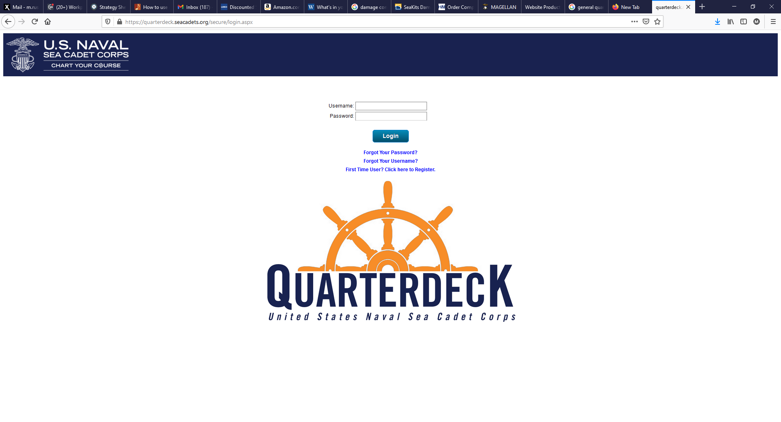
Once you are logged in, you will see this page:

Hover your cursor over the “Homeport” icon and select. You should see this page:

- Hover over and select the “Training List” button near the bottom of the page.
You will then see a screen that looks like the one below. Take some time to look at various training topics. Typically, there are some 400 trainings all over the United States, Hawaii, Guam and Puerto Rico available for Cadets to attend. Before you can sign up for any other trainings, you must first complete Sea Cadet Recruit Training or League Cadet Orientation
Sea Cadet RT is listed under “Navy Shore, NSCC Recruit Training.”
League Cadet Orientation is listed under “NLCC Orientation, Basic.”
NOTE: You may sort the trainings in various ways (ie by state or month) using the buttons right above the “Events by Subject” list.
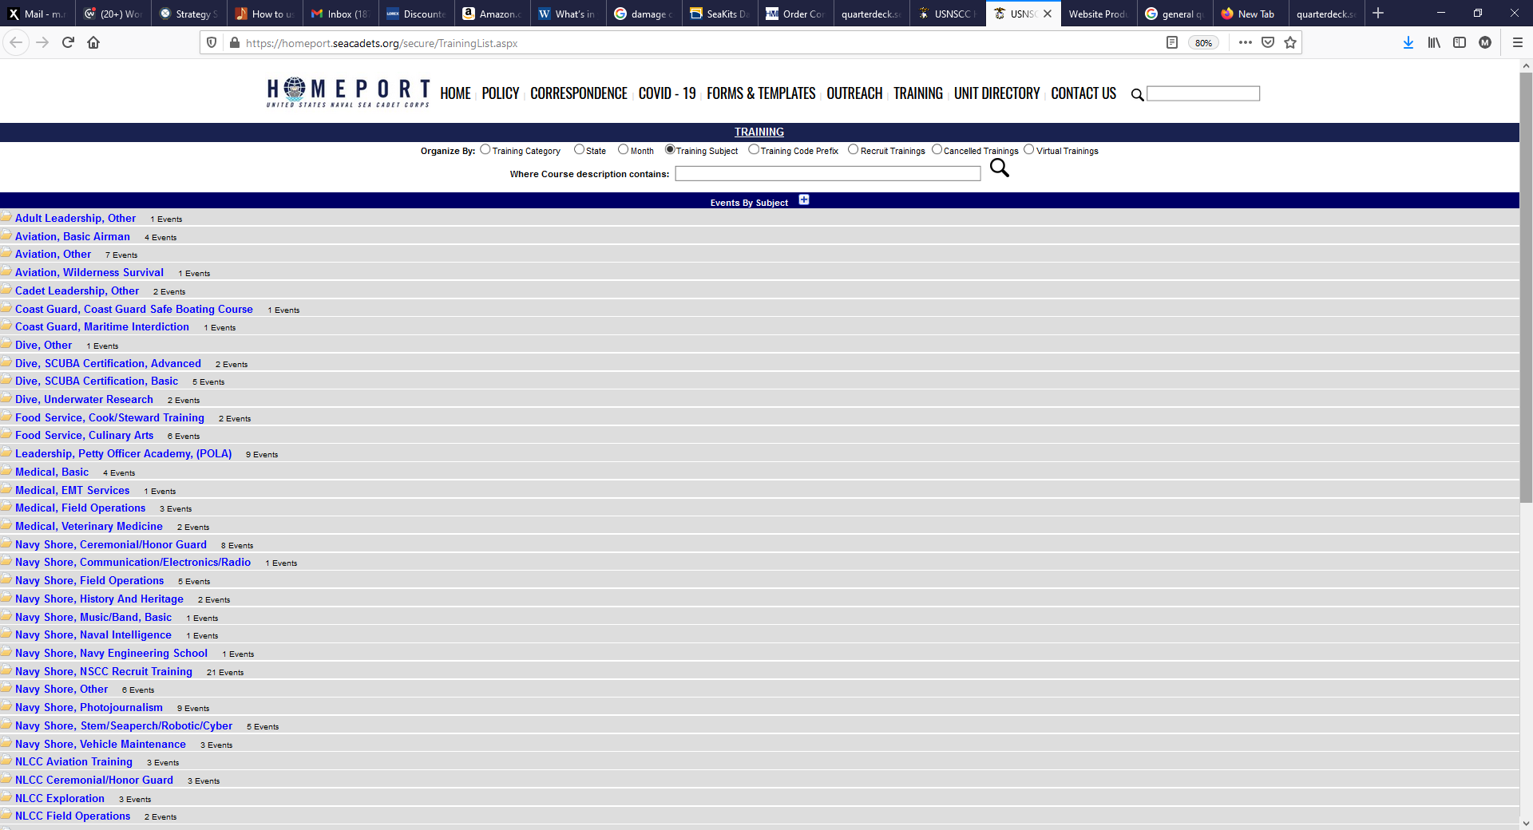
Once you have found a training that interests you (e.g. NavyShore, NSCC Recruit Training), select the training type and the list will expand to show all trainings being offered in that category that are available as shown below (example for RT shown below):
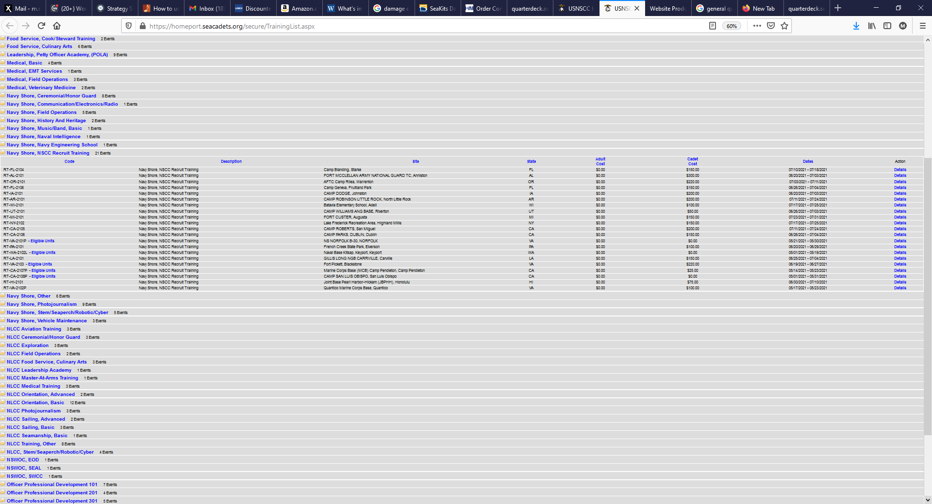
(“Eligible Units” means that attendance is limited to local units only.)

How to access Training-specific Details:
Select “Details” (in blue on the right-hand side of the list). For this example, we will look at NSCC Recruit Training in UT. You will see a page that looks like the screen shot below that provides very important information:
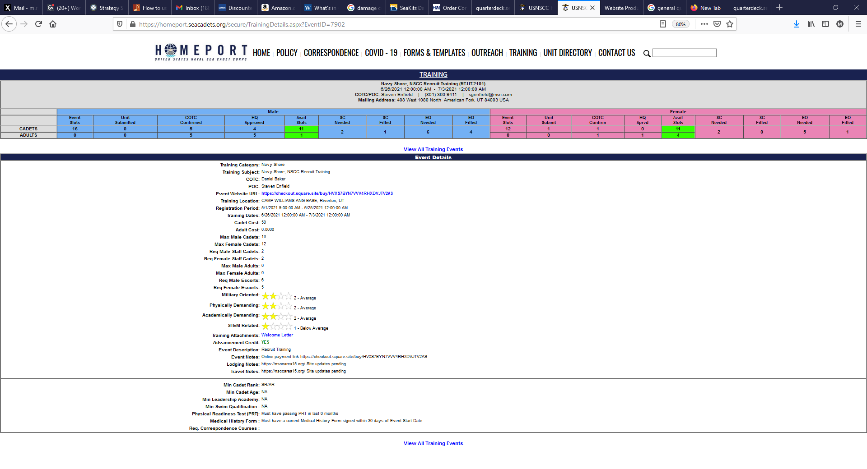

- CONTACT INFORMATION
Here we see the training code (RT-UT-2101). We see the Commanding Officer of the Training Contingent (COTC) point of contact (POC) information.
- AVAILABLE SPACES The next bar shows how many slots are available. If the number “available” (“11” highlighted in green here) is “0”, you need to find a different training. There are separate slot availabilities for male and female cadets (shaded blue and magenta).
- The next critical items are the Event Notes and the traveling notes. In this case, it tells you where to pay on-line (https://checkout.square.site/buy/HVXS7BYN7VVV4RHXDVJTV2AS). Lodging and travel notes are pending but the parent is directed to a website for more information, in this case, https://nsccarea15.org/.
If you were traveling out of state, this would have important information about travel arrangements. For local trainings at Camp Williams, you will need to be dropped of by car and then picked up at the end of the training.

- TRAINING QUALIFICATIONS – Pay attention to this for all Trainings but especially for Trainings involving Special Ops since there may be many additional requirements.
Note here that there is a minimum rank, age, requirement for successful passing of the PRT and a medical history form signed within 30 days of the event. We will discuss these forms (NSCTNG001) a bit later.

- COURSE RATINGS:

Review the materials. PRINT (!) the Welcome Letter, Sea Bag List (often in welcome letter) and Travel Information Sheet if applicable.
ONCE YOU HAVE Confirmation, Follow the “On-line Payment” Instructions. YOUR CADET WILL NOT EVEN BE CONSIDERED IF IT IS NOT PAID FOR IN ADVANCE. DO NOT PAY FOR TRAININGS THAT ARE FULL!!
NOTE: YOU CANNOT REGISTER YOUR CADET IN MAGELLAN. THIS WILL BE DONE BY THE UNIT. SEE INSTRUCTIONS BELOW ENTITLED: HOW TO INITIATE TRAINING
How to Initiate Training
It is important to understand that although payment is done on-line by parents, direct registration for trainings must be done by the local Sea Cadet Command Staff in order to generate the training documentation required.
Here is the process:
- CONTACT UNIT LEADERSHIP Once you and your cadet determine which course he/she wants to take and have verified that the cadet meets the qualifications (!), the Cadet (not the parent or guardian) should send the CO an email (with Parents copied!!!) stating that he/she would like to register for a training, specifying the name and ID of the requested training (i.e. “Recruit Training 2021, (RT-UT-2101”). The CO will register the Cadet in the training process. There are then a number of forms required to get the cadet signed up, and it is most helpful and saves time to have the forms filled out as completely as possible!
2) TRAINING REQUEST/WAIVER FORM
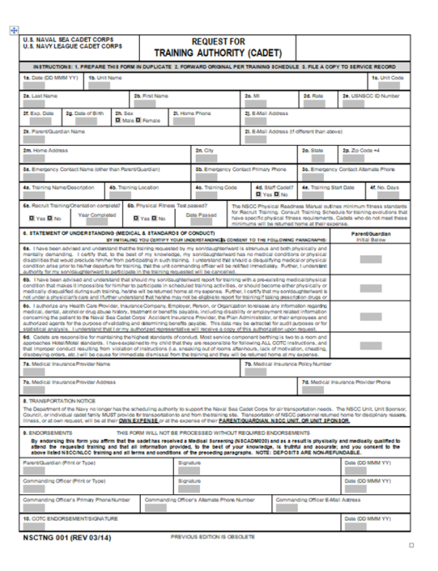
The CO will respond to the Cadet with an Email that includes the first form, NSCTNG001 “Request for Training Authority (Cadet)”, and a screen shot of the specific training that he/she has selected. The NSCTNG001 form should have most of information already filled out based on information on file with Magellan. Initial the waiver statements and sign the form. If any information is incorrect, please correct with a single line-out and correct information written above, initial and sign the form and submit it back to the CO.
3) TRAINING REGISTRATION/PAYMENT
The CO will review it for completeness and sign the form. The CO will then register the cadet. The training is then available for payment, which must be done to fully register the cadet. Some trainings fill quickly, so ideally payment is made immediately after the CO registers the cadet.
4) MEDICAL FORMS
Upon notification of successful initial enrollment, the CO will send the next form, NSCADM 001 “Report of Medical History” (pages 3-4 ONLY). The first form, NSCTNG001, should have some information already filled out including the Unit Name: Jake Garn Squadron; and the Region: 15-1, plus information that is on file in our computer system called Magellan.
Figure 1. Register Training Authority Form NSCTNG 001.
Please note: The NSCADM 001 Medical History Form does NOT have to be signed by a physician (we have the full form on record, signed by your primary care physician). The purpose of this form is to ensure that nothing significant has changed in your Cadet’s health. The form must be completed, signed and dated WITHIN 30 DAYS OF ARRIVING AT TRAINING. If it is signed outside this 30 day window, IT WILL BE REJECTED AND YOU WILL HAVE TO COMPLETE THE FORM AGAIN within the 30 day window.

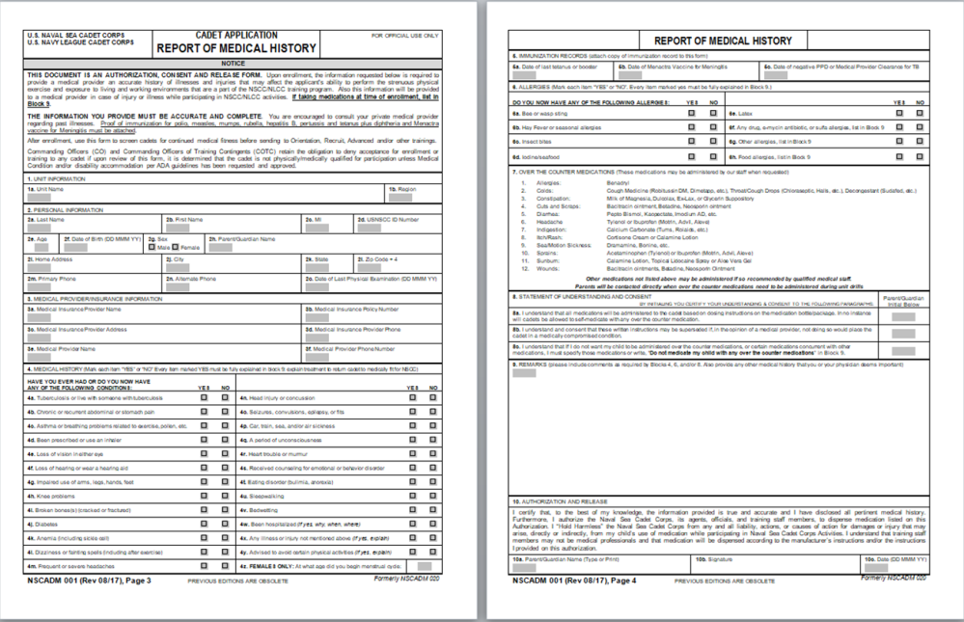
Figure 3. Medical History Supplemental form for Cadets taking prescription medications. This form is only necessary if your Cadet is taking Prescription Medications.

Figure 2. Report of Medical History pages 3-4. This Document is always required and must be signed within 30 days of the first day of training.

5) TRAVEL ARRANGEMENTS
Travel must be arranged and paid for by the parents, and an itinerary provided to the home unit CO. The Itinerary will be placed prominently in the Cadet’s Service Jacket (personnel file). Note: The USNSCC recommends that refundable tickets be purchased in the event of Cadet illness or unexpected cancellation. This is an individual family decision. For local training, parents may simply drop the Cadet off at Camp Williams and pick them up at the end of the training.
6) PREPARE SEA BAG
It is CRITICAL that your Cadet review the Sea Bag List well in advance of the departure for training. These lists are very useful and comprehensive, and detail what items are necessary and sufficient for the training. If additional uniforms are required by the training, uniforms and NAME TAPES will have to be obtained from Supply. NAME TAPES take time to order, so do not delay in advising the unit that they are needed! The same goes for dress uniform name plates!! Each cadet is responsible to ensure that they have the necessary uniforms with patches properly applied and that they are clean, ironed and ready for inspection at training. Ribbons should be in proper order and prepared to be worn at graduation (and any time training would require they be in dress blues/whites).
7) FINALLY: READY FOR LAUNCH
The Service Jacket (Personnel Record) —> Think of it as an Admission Ticket to training
Each Cadet’s Service Jacket will be prepared and placed in a sealed envelope by your home unit for delivery to the training. This contains critical medical, insurance, emergency contact information, etc., for your Cadet. If your Cadet is traveling to another state, they must take their Service Jacket with them. It is critical that your Cadet obtains their Service Jacket prior to departure and packs it in a carry-on bag. The cadet must return the Service Jacket back to the unit after completion of the training.
NOTE: For Local Training, the CO will deliver the Service Jackets directly to/from Camp Williams.*

