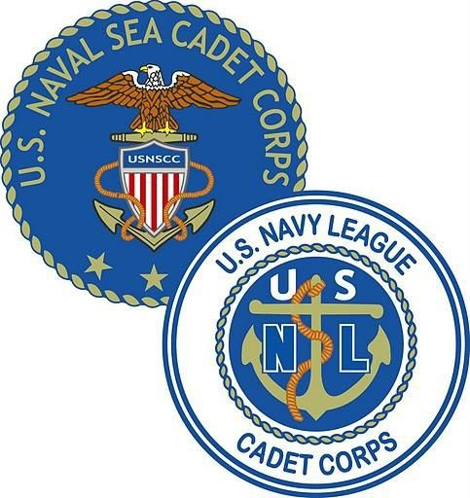
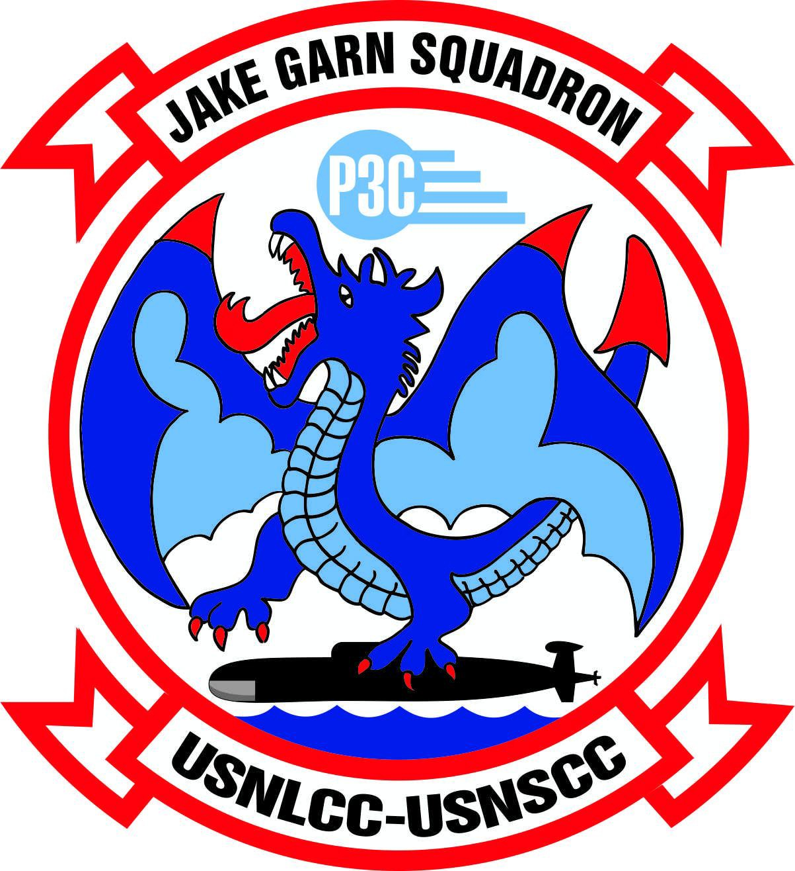
U.S. NAVAL SEA CADET CORPS
JAKE GARN SQUADRON
5120 S 1050 W
Riverdale, Utah 84315 www.seacadetsutah.org

PLAN OF THE MONTH

The Plan of the Month is an official document of JAKE GARN SQUADRON. Its contents reflect current orders of the Commanding Officer and official unit announcements. All Division personnel are responsible for reading and understanding the information contained herein. Parents and guardians of Cadets are encouraged to read the Plan of the Month and to make note of meeting days and special announcements that may affect personal schedules.

STARTING DEC, 2020, DRILL SHALL CONSIST OF 3 HOUR VIRTUAL DRILL ON SATURDAYS MORNING FROM 0900-1200. CADETS SHALL MUSTER IN-PERSON AT THE UTAH MILITARY ACADEMY ON SATURDAY AFTERNOON AT 1400 TO RETRIEVE DRILL ACTIVITY SUPPLIES. NO DRILL WILL BE CONDUCTED ON SUNDAY.

05 DEC 2020

LTJG Marc Russon, NSCC COMMANDING OFFICER 801-209-3213

LT C. Putnam, NSCC
EXECUTIVE OFFICER
INST J. LaSeure, NSCC COMMAND DUTY OFFICER
INST E. Stockmaster, NSCC OPERATIONS OFFICER

Drill Hours: Saturday, 0900-1200 Hours Sunday, 0700-1500 Hours

Uniform of the Day: 05 DEC
Officers/CPOs: Cadets:
NWUs/Alternate
NWUs

LPO: CPO Putnam
Saturday POD |  |  | Sunday POD
0845  0900 | Morning Muster ZOOM Video Conference  Roll Call and Video Call Etiquette |  |  | NO IN-PERSON DRILL ON SUNDAYS UNTIL FURTHER NOTICE
0905 | Announcements
0930 | Training Subject: History of Navy Space Innovation
1030 | Break
1040 | How Rockets and Satellites work (STEM)
1150 | Building your rockets
1200 | Dismiss Zoom Call
1400 | Muster at UMA to Pick up Rocket Kits and Uniform Items

Notes: Use your video Invitation to join the meeting.

Polaris Registration: All Coursework is not handled on-line. You must register in Polaris in order to find your coursework. This is accomplished by searching in your web browser: www.seacadets.org. Once on this page, you will see the “Login” button in the upper right hand corner. Selecting this button will take you to the Quarterdeck Login page. For new users, select “First Time User? Click here to Register”. Fill out the information requested. Your USNSCC ID number is found on your ID.

Once you have your login username and password, you will be able to access Polaris and find your coursework. Please be advised that the BMR has been retired as of 31 December. All Recruit Cadets should transition to completing the E1 and E2 coursework. If you have questions regarding which coursework you should be working on, please contact the CO.

All Cadets are required to turn in at least one (1) coursework assignment per drill.

CHOW: Cadets are required to bring a sack lunch for chow Saturday and Sunday. There is not enough time allotted for cadets to leave the premises to get lunch.

*Watch: Cadets scheduled for morning watch will show up to drill in NWUs (all other cadets will show up in P/T uniform). The cadets scheduled for Saturday and Sunday watch will be notified prior to drill

ENROLLMENT FEES - The cost of re-enrollment is $175.00. If you are coming up on your re-enrollment date, please ensure you coordinate renewal with the Executive Officer. The new fee to join the program is $240.00

Re-enrollment coming up or that have lapsed:

- November: SA-Bevan
- December: SR Kingdon
- January: None

ATTENDANCE - NSCC Regulations state that you must attend 75% of all scheduled drills. That is four of six drills per quarter. If you do not meet this standard, you will be administratively warned. If you continue to fail to meet minimum attendance standards, you will be discharged from the NSCC/NLCC. IF you are going to miss a portion of or all of drill, the CO is required to know BEFORE drill. Credit for the drill is dependent on when you report to the unit each day.

PRT REQUIREMENTS: PRT Requirements can be found here: http://homeport.seacadets.org/display/Manuals/Physical+Readiness+Manual

You can look up male/female and by age to see what is required for each exercise. It also shows the proper technique.

CADET LEADERSHIP - We will be working with our leading cadets to give them opportunities to lead within the unit. This will include but is not limited to: partnering with a cadet for studying/test prep, teaching a cadet a specific skill, conducting a 2-hour interactive training on a specific topic to unit, helping a cadet create 2-hour interactive training, etc.

RECRUITING - One of our greatest needs at the moment is to grow our numbers of cadets AND adult leadership. With this, the officers and cadets will start talking to those with interest and/or military experience that could benefit from our program or give back to our program in quality ways.
COMMUNITY INVOLVEMENT - We would like to increase our community involvement and awareness of our squadron. We will be reaching out to the local VA hospital to do visits, increasing our exposure at local events like football games, coordinating with military groups or businesses that have a desire to give back to our youth!

We look forward to hearing from you of any ideas you have where our faces and name can be shared!

PARENT AUXILIARY- We want you to be more involved with what we do as a unit. There are several opportunities that our auxiliary can support us: fundraising coordination/follow through, meal planning for overnight drills, year-end celebration, etc. We would like to have your expertise enhance your cadet’s experience within the unit! We will be reaching out to you individually over the coming months.
SPONSORED BY THE AMERICAN LEGION POST 27, FARMINGTON, UTAH
http://www.seacadetsutah.org

